
  Eco Audit Report
  Product name
  Jet Engine Blade
  Country of use
  The Whole World
  Product life (years)
  3
Summary:

 |  | 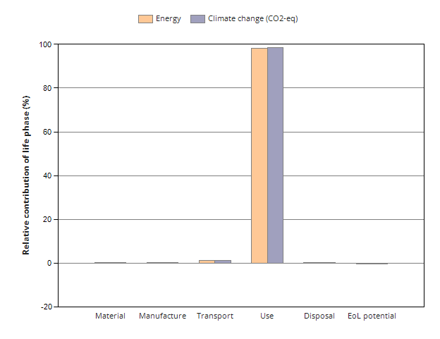
  Energy details
  Climate change (CO2-eq) details
Phase | Energy  (MJ) | Energy  (%) | Climate change (CO2-eq)  (kg) | Climate change (CO2-eq)  (%)
Material | 1.79e+07 | 0.4 | 1.01e+06 | 0.3
Manufacture | 1.3e+06 | 0.0 | 1.01e+05 | 0.0
Transport | 5.98e+07 | 1.3 | 4.01e+06 | 1.2
Use | 4.49e+09 | 98.3 | 3.23e+08 | 98.4
Disposal | 3.22e+04 | 0.0 | 2.25e+03 | 0.0
Total (for first life) | 4.56e+09 | 100 | 3.28e+08 | 100
End of life potential | -6.63e+06 |  | -3.18e+05

Eco Audit Report

Summary

Energy Analysis

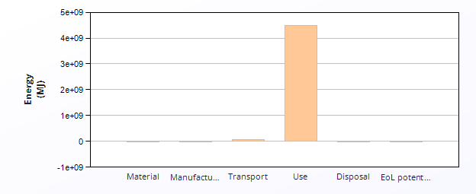
 | Energy (MJ/year)
Equivalent annual environmental burden (averaged over 3 year product life): | 1.52e+09

Detailed breakdown of individual life phases

  Material:
  Summary
Component | Material | Recycled content*  (%) | Part mass  (kg) | Qty. | Total mass  (kg) | Energy  (MJ) | %
Super Ni Blade | Nickel-based superalloys | Virgin (0%) | 23 | 1000 | 2.3e+04 | 7.8e+06 | 43.6
Med Carbon Blade | Medium carbon steel | Virgin (0%) | 23 | 1000 | 2.3e+04 | 7.3e+05 | 4.1
Stainless Steel Blade | Stainless steel | Virgin (0%) | 23 | 1000 | 2.3e+04 | 1.6e+06 | 8.8
Super Power Blade | Nickel-based superalloys | Virgin (0%) | 23 | 1000 | 2.3e+04 | 7.8e+06 | 43.6
Total |  |  |  | 4000 | 9.2e+04 | 1.8e+07 | 100

*Typical: Includes 'recycle fraction in current supply'

***User-defined material

  Manufacture:
  Summary
Component | Process | Amount processed |  | Energy  (MJ) | %
Super Ni Blade | Casting | 2.3e+04 | kg | 2.5e+05 | 19.1
Med Carbon Blade | Forging | 2.3e+04 | kg | 1.2e+05 | 9.2
Stainless Steel Blade | Forging | 2.3e+04 | kg | 1.2e+05 | 9.1
Super Power Blade | Metal powder forming | 2.3e+04 | kg | 8.1e+05 | 62.5
Total |  |  |  | 1.3e+06 | 100

  Transport:
  Summary
Breakdown by transport stage

Stage name | Transport type | Distance  (km) | Energy  (MJ) | %
Ground Unit | Truck 16-32t, EURO 6 | 2e+05 | 5.3e+07 | 89.0
Sea Unit | Sea, container ship | 5.3e+05 | 6.6e+06 | 11.0
Total |  | 7.3e+05 | 6e+07 | 100

Breakdown by components

Component | Mass  (kg) | Energy  (MJ) | %
Super Ni Blade | 2.3e+04 | 1.5e+07 | 25.0
Med Carbon Blade | 2.3e+04 | 1.5e+07 | 25.0
Stainless Steel Blade | 2.3e+04 | 1.5e+07 | 25.0
Super Power Blade | 2.3e+04 | 1.5e+07 | 25.0
Total | 9.2e+04 | 6e+07 | 100

  Use:
  Summary
Mobile mode

Fuel and mobility type | Kerosene - long haul aircraft
Country of use | The Whole World
Product mass  (kg) | 9.2e+04
Distance  (km per day) | 1e+04
Usage (days per year) | 2.5e+02
Product life (years) | 3

  Relative contribution of static and mobile modes
Mode | Energy  (MJ) | %
Static | 0
Mobile | 4.5e+09 | 100.0
Total | 4.5e+09 | 100

Breakdown of mobile mode by components

Component | Energy  (MJ) | %
Super Ni Blade | 1.1e+09 | 25.0
Med Carbon Blade | 1.1e+09 | 25.0
Stainless Steel Blade | 1.1e+09 | 25.0
Super Power Blade | 1.1e+09 | 25.0
Total | 4.5e+09 | 100

  Disposal:
  Summary
Component | End of life option | Energy  (MJ) | %
Super Ni Blade | Downcycle | 1.2e+04 | 35.7
Med Carbon Blade | Landfill | 4.6e+03 | 14.3
Stainless Steel Blade | Landfill | 4.6e+03 | 14.3
Super Power Blade | Downcycle | 1.2e+04 | 35.7
Total |  | 3.2e+04 | 100

EoL potential:

Component | End of life option | Energy  (MJ) | %
Super Ni Blade | Downcycle | -3.3e+06 | 50.0
Med Carbon Blade | Landfill | 0 | 0.0
Stainless Steel Blade | Landfill | 0 | 0.0
Super Power Blade | Downcycle | -3.3e+06 | 50.0
Total |  | -6.6e+06 | 100

  Notes:
  Summary

Eco Audit Report

Summary

Climate Change (CO2-eq) Analysis

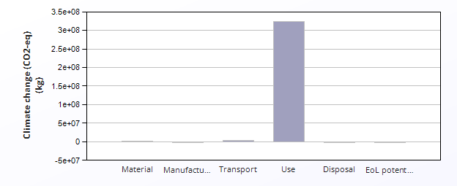
 | CO2 (kg/year)
Equivalent annual environmental burden (averaged over 3 year product life): | 1.09e+08

Detailed breakdown of individual life phases

  Material:
  Summary
Component | Material | Recycled content*  (%) | Part mass  (kg) | Qty. | Total mass  (kg) | Climate change (CO2-eq)  (kg) | %
Super Ni Blade | Nickel-based superalloys | Virgin (0%) | 23 | 1000 | 2.3e+04 | 4.1e+05 | 40.7
Med Carbon Blade | Medium carbon steel | Virgin (0%) | 23 | 1000 | 2.3e+04 | 5.4e+04 | 5.3
Stainless Steel Blade | Stainless steel | Virgin (0%) | 23 | 1000 | 2.3e+04 | 1.3e+05 | 13.4
Super Power Blade | Nickel-based superalloys | Virgin (0%) | 23 | 1000 | 2.3e+04 | 4.1e+05 | 40.7
Total |  |  |  | 4000 | 9.2e+04 | 1e+06 | 100

*Typical: Includes 'recycle fraction in current supply'

***User-defined material

  Manufacture:
  Summary
Component | Process | Amount processed |  | Climate change (CO2-eq)  (kg) | %
Super Ni Blade | Casting | 2.3e+04 | kg | 1.9e+04 | 18.4
Med Carbon Blade | Forging | 2.3e+04 | kg | 9e+03 | 8.9
Stainless Steel Blade | Forging | 2.3e+04 | kg | 8.9e+03 | 8.8
Super Power Blade | Metal powder forming | 2.3e+04 | kg | 6.5e+04 | 64.0
Total |  |  |  | 1e+05 | 100

  Transport:
  Summary
Breakdown by transport stage

Stage name | Transport type | Distance  (km) | Climate change (CO2-eq)  (kg) | %
Ground Unit | Truck 16-32t, EURO 6 | 2e+05 | 3.5e+06 | 87.6
Sea Unit | Sea, container ship | 5.3e+05 | 5e+05 | 12.4
Total |  | 7.3e+05 | 4e+06 | 100

Breakdown by components

Component | Mass  (kg) | Climate change (CO2-eq)  (kg) | %
Super Ni Blade | 2.3e+04 | 1e+06 | 25.0
Med Carbon Blade | 2.3e+04 | 1e+06 | 25.0
Stainless Steel Blade | 2.3e+04 | 1e+06 | 25.0
Super Power Blade | 2.3e+04 | 1e+06 | 25.0
Total | 9.2e+04 | 4e+06 | 100

  Use:
  Summary
Mobile mode

Fuel and mobility type | Kerosene - long haul aircraft
Country of use | The Whole World
Product mass  (kg) | 9.2e+04
Distance  (km per day) | 1e+04
Usage (days per year) | 2.5e+02
Product life (years) | 3

  Relative contribution of static and mobile modes
Mode | Climate change (CO2-eq)  (kg) | %
Static | 0
Mobile | 3.2e+08 | 100.0
Total | 3.2e+08 | 100

Breakdown of mobile mode by components

Component | Climate change (CO2-eq)  (kg) | %
Super Ni Blade | 8.1e+07 | 25.0
Med Carbon Blade | 8.1e+07 | 25.0
Stainless Steel Blade | 8.1e+07 | 25.0
Super Power Blade | 8.1e+07 | 25.0
Total | 3.2e+08 | 100

  Disposal:
  Summary
Component | End of life option | Climate change (CO2-eq)  (kg) | %
Super Ni Blade | Downcycle | 8.1e+02 | 35.7
Med Carbon Blade | Landfill | 3.2e+02 | 14.3
Stainless Steel Blade | Landfill | 3.2e+02 | 14.3
Super Power Blade | Downcycle | 8.1e+02 | 35.7
Total |  | 2.3e+03 | 100

EoL potential:

Component | End of life option | Climate change (CO2-eq)  (kg) | %
Super Ni Blade | Downcycle | -1.6e+05 | 50.0
Med Carbon Blade | Landfill | 0 | 0.0
Stainless Steel Blade | Landfill | 0 | 0.0
Super Power Blade | Downcycle | -1.6e+05 | 50.0
Total |  | -3.2e+05 | 100

  Notes:
  Summary

